

**Assessment Brief**

**Advanced Programming**

**Tutor Name: Ms. Amritha Dhanesh**

**Tutor Contact Details: amritha@metaverseage.ae**

**The Brief**

The programming skills portfolio requires you to develop solutions to a series of coding exercises. These exercises will test your knowledge of the programming techniques introduced through the course of the module and are designed to give you freedom with the techniques you use to solve the challenges. When solving the exercises you should aim to select the techniques that are most appropriate for the task and allow you to demonstrate the breath of knowledge acquired through the module. The exercises can be found in *Programming Skills Portfolio* folder of your CodeLab II GitHub repository GITHUB LINK :[ASSESSMENT 1(Programming skills Portfolio)](https://github.com/lavanand/CODELAB-2--A1)

When completing the exercises you should create a new project for each one and save these to the *Programming Skills Portfolio* folder in your repository. Each exercise should be appropriately named (e.g. 01-MathsQuiz) so they are easy to find. You should commit changes in your repository often and use descriptive messages for these commits and ensure you are regularly pushing your code back to GitHub.

* In addition to completing the exercises listed below you should complete the following online course on

SoloLearn - Intermediate Python <https://www.sololearn.com/en/learn/courses/python-intermediate>

Great Learning - Python Tkinter - <https://www.mygreatlearning.com/academy/learn-for-free/courses/python-tkinter#fpc-section>

   Completion of this course is worth 20% of the assessment marks.

**Deadlines**

The deadline for the Programming Skills Portfolio assessment is **1st November, 11:59am.**

All deadlines are 11:59am, only code submitted before the deadline will be marked. Mark penalties may be applied to late submissions without prior approval of an extension. Please ensure that you prepare and submit your work in good time to allow for any issues that may arise.

Assessment feedback will be returned within 15 working days from the deadline date for submission.

**Deliverables**

The deliverables for this assignment are as follows:

* Your python code in response to the programming skills portfolio exercise(s). Code must be pushed to your GitHub repository before the corresponding deadlines listed above.

Certificate of completion for the

* SoloLearn - Intermediate Python <https://www.sololearn.com/en/learn/courses/python-intermediate>
* Great Learning - Python Tkinter - <https://www.mygreatlearning.com/academy/learn-for-free/courses/python-tkinter#fpc-section>

**Submission**

To submit your work you should ensure your code for the required chapter exercises has been submitted to your GitHub repository. Please adhere to the following method:

* Check your exercises are functioning as expected.
* Commit and push your code to your GitHub repository.
* Copy the links to each exercise required by the submission in your repository
* Paste the links into the submission portal
* Upload your certificate of completion for the

SoloLearn - Intermediate Python <https://www.sololearn.com/en/learn/courses/python-intermediate>

Great Learning - Python Tkinter - <https://www.mygreatlearning.com/academy/learn-for-free/courses/python-tkinter#fpc-section>

Only code pushed to your Github repository before the assessment deadline will be marked. Ensure you give yourself enough time before your final push. Guides on how to push your code to GitHub are provided on Minerva. If you are unsure ask your tutor.

**Use of online sources**

If you take any code from online resources (including Generative AI tools) to support the development of your program you should fully acknowledge their use by referencing the source in your code comments.

* Code Comments: A reference in the code comments should be added ahead of the section of code that has been taken or heavily developed using online resources.
* *For standard online sources you should include the title of the webpage and full URL.*
* *For Generative AI tools you should include the name of the tool and the prompt provided to generate the code.*

If you are unsure of how to appropriately reference please consult your tutor. Failure to appropriately acknowledge use of online resources may result in an [academic misconduct](https://www.bathspa.ac.uk/about-us/governance/policies/academic-misconduct/) accusation.

Also be aware that use of online resources to develop your code should be kept to a minimum and excessive use may be deemed academic misconduct. The flowchart below is offered as guidance to what is and is not acceptable. Again if you are unsure please consult your tutor.

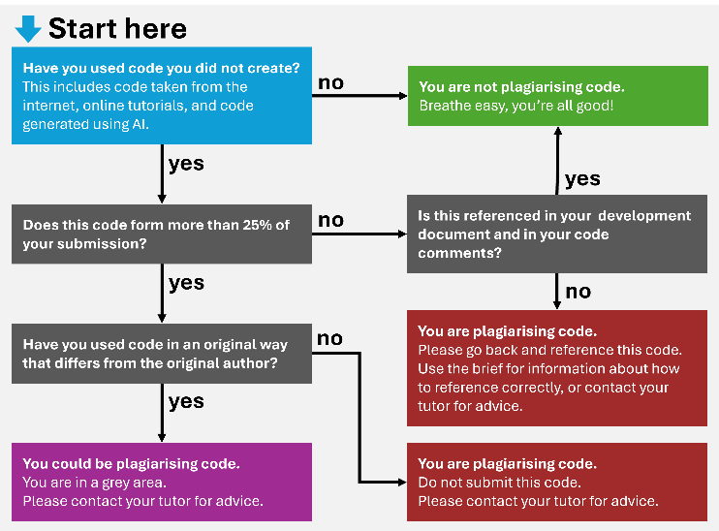

**Marking Criteria**

Each skills portfolio submission will be evaluated against the following criteria

1. Technical Implementation (70%)
2. Repository Presentation (10%)
3. Extended Learning (20%)

|  |  |  |  |
| --- | --- | --- | --- |
| **Criteria** | **Weighting** | **Mark Range Description** | **Mark Range** |
| **Technical Implementation** | **90%** | Solutions are either missing or contain significant errors and do not compile. Overall limited evidence of the taught techniques are demonstrated. | 0 - 19  (Low Fail) |
|  |  | Poor solutions that may not fully complete the stated task or feature significant errors. Little to no adherence to coding conventions | 20 - 39  (Fail) |
|  |  | Basic solutions that demonstrate a limited understanding or utilise a limited range of programming techniques. All exercises attempted but may be incomplete or feature errors. Limited adherence to coding conventions | 40 - 49  (Third) |
|  |  | Fair solutions that show an understanding of the techniques introduced in the module. Exercises are complete although may not use the most efficient method. Coding conventions have mostly been adhered to. | 50 - 59  (2:2) |
|  |  | Good solutions that demonstrate a sound understanding of programming techniques introduced in the module. The solutions give some consideration to programming efficiency, but with room for improvement. Coding conventions have been followed with only minor slips in detail. | 60 - 69  (2:1) |
|  |  | Very good code that provides efficient solutions to the coding challenges which push them beyond their base requirements. Strong understanding of programming techniques is evident and may include use of techniques beyond the scope of class. Code is structured and commented to a very good standard. | 70 - 79  (First) |
|  |  | Excellent solutions that extend the coding challenges to demonstrate techniques outside the scope of the class. Code is structured and commented to a high standard. | 80 - 89  (High First) |
|  |  | Beyond expectations for this level of study. | 90 - 100  (Outstanding) |
| **Repository Presentation** | **10%** | Limited repository organisation that does not adhere to the method specified. | 0 - 19  (Low Fail) |
|  |  | Poor repository organisation with unclear exercise naming. Some exercises are saved in incorrect locations making them difficult to find. Commit messages lack description and code is likely pushed in a single commit. | 20 - 39  (Fail) |
|  |  | Basic repository organisation. Some exercises may be difficult to find. Commit messages are basic and would benefit from further clarity. Code is pushed on an irregular basis. | 40 - 49  (Third) |
|  |  | Fair repository organisation, though there may be some minor slips in presentation. Commit messages are good, though there is room for refinement. Code is pushed on a semi-regular basis | 50 - 59  (2:2) |
|  |  | Good repository organisation, though some exercises may need better naming conventions. Commit messages are good, though there is room for refinement. Code is pushed regularly. | 60 - 69  (2:1) |
|  |  | Very good repository organisation, exercises are easy to find and clearly labelled. Commit messages are clear with code frequently pushed. | 70 - 79  (First) |
|  |  | Excellent highly organised repository, with clear commit messages. Code is pushed very frequently. | 80 - 89  (High First) |
|  |  | Beyond expectations for this level of study. | 90 - 100  (Outstanding) |
| ​**Extended Learning** | **​20%** | ​Completion certificate for the specified course has not been provided. | ​​0  (Fail) |
| ​ | ​ | ​Completion certificate for the specified course has been provided. | ​100  (Pass) |

**Intended Learning Outcomes**

|  |  |
| --- | --- |
| **ILO** | **Assessed** |
| The implementation and testing of a prototype system that is driven by object-oriented programming techniques. | ✓ |
| Application of the iterative design cycle of prototyping, testing, analysing and refinement. | ✓ |
| A recognition of personal knowledge limits, which is addressed through the identification of learning opportunities. |  |
| An ability to critically review the key features and challenges of developing software for an end user, and evaluate their relevance to the field of creative computing. |  |